**Overview**

The PayPal JSV4 integration allows Merchants to use PayPal's newest javascript integration in order to launch the PayPal authentication screen. With this implementation, there is no longer a need to have the Merchant code to the form redirect that they have in the past. When they receive the lookup response back, they will take the EC Token returned on the response and feed it into PayPal's javascript to launch the PayPal authentication window. Once they return back from PayPal, they will run the cmpi_authenticate message to retrieve back the consumer details and status. Everything else after the cmpi_authenticate will stay the same as a standard integration.

**PayPal Documentation**

JSV4 with soap:   
<https://developer.paypal.com/docs/integration/direct/express-checkout/integration-jsv4/upgrade-integration/>   
  
JSV4 button   
<https://github.com/paypal/paypal-checkout/blob/master/docs/performance.md>

**Jira Documentation**

[[https://cardinalcommerce.atlassian.net/images/icons/issuetypes/epic.png](https://cardinalcommerce.atlassian.net/browse/CEN-660)CEN-660](https://cardinalcommerce.atlassian.net/browse/CEN-660) - Updates to support new PayPal JSV4 Javascript Implementation Within Centinel **READY**

**Merchant Level Configurations**

| **Config Field** | **Description** |
| --- | --- |
| JSV4 Enabled | This flag will enable the JSV4 flows. This includes EC Token being returned on the lookup response and no ACSUrl being returned.  Disabled - Standard flow will be used  Enabled - JSV4 flow will be used only when the OverrideJSV4Enabled is set to true or empty. |

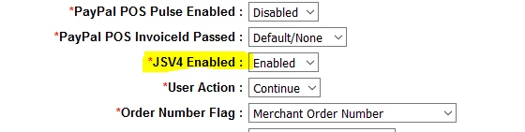

This configuration can also be set or overridden on the Lookup Request using the following field:

| **Field Name** | **Description** |
| --- | --- |
| OverrideJSV4Enabled | API override field that is used to enable the JSV4 flow at the transaction level. This field will override the "JSV4 Enabled" configuration on the Merchant account.  true - JSV4 flow will be used  false - Standard flow will be used  Note: When this field is empty, then JSV4 flow will be used if the config field is enabled. |

**API Updates to Lookup Response**

| **Field Name** | **Description** |
| --- | --- |
| ProcessorTransactionId | This field will return the PayPal EC-Token value that is needed to seed the PayPal JSV4 javascript in order to launch the PayPal authentication screen. |